What is MCB (Miniature Circuit Breaker)

MCBs are the circuit breakers typically found in most modern households. They are basically re-settable fuse. They can trip with two modes. First mode is slow and the trip action is due to temperature rise due to prolonged high current. The second mode is much faster which is meant to protect under short circuit conditions. The second mode has a trip reaction time of 100ms, which means that after dectecting a short, the circuit breaker can break the current within 100ms.

MCBs look like this:  
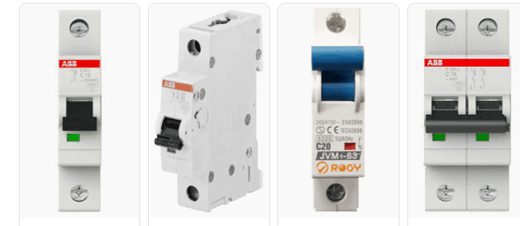

**Types of MCB**

MCBs have a rated trip current. And it addition to that, MCB also have the so called trip curves. These trip curves vary from C,B,D,A and even Z. Trip curves shows at what current the MCB will trip practically instantly. For example. For an MCB with a trip “B” trip curve, The MCB will instantly trip at 3-5 times the rated full load current, while an MCB with a “C” trip curve will instantly trip at 5-10 times of the rated full load current. Below is the trip curves (https://www.electricalclassroom.com/b-c-d-k-and-z-mcb-trip-curves/).

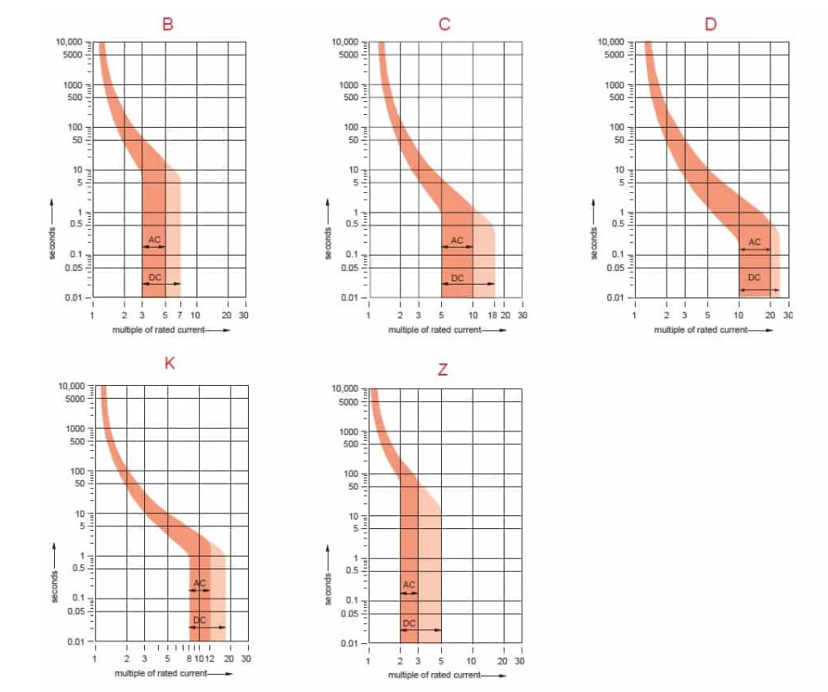

**What type of MCB is used for home?**

Seems like either MCBs that have B or C trip curves are used for home applications. See snapshot below(https://www.consumerunitworld.co.uk/what-is-an-mcb-and-how-does-it-work-328-c.asp).

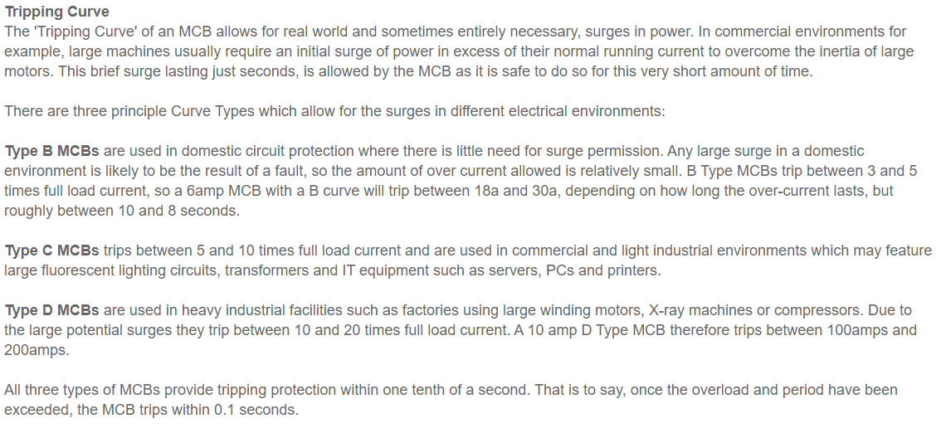

Further

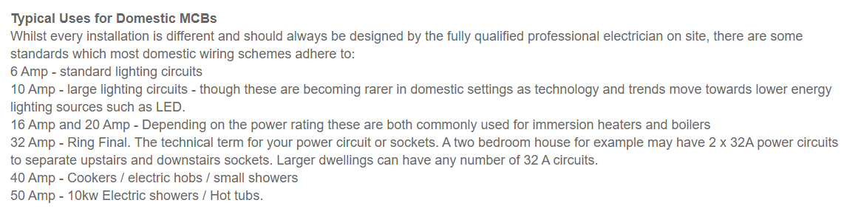

**Conclusion**

MCBs used in power sockets are likely to be 16-32A MCBs that have either “B” (3-5 x full current) or “C” (5-10 x full current).

I had a look at the MCBs of a house (@ snapperrock) it seems that the lights uses C10A , while power uses C16A or C20A. I am assuming power means the power sockets.

Ofcourse, the power sockets have other circuits connected to it that why the trip current is probably higher. But there is no way of knowing what circuits are connected to what loop.

Links

<https://www.electricalclassroom.com/b-c-d-k-and-z-mcb-trip-curves/>

<https://www.consumerunitworld.co.uk/what-is-an-mcb-and-how-does-it-work-328-c.asp>

<https://uk.rs-online.com/web/generalDisplay.html?id=ideas-and-advice/mcb-guide>